Bullock School Is Participating In:

|  |
| --- |
| A black background with orange dotsUNITY DAY  **October 16th, 2024 - Wednesday**  Wear and Share Orange  Come Together Against Bullying,  United for Kindness,  Acceptance, and Inclusion |

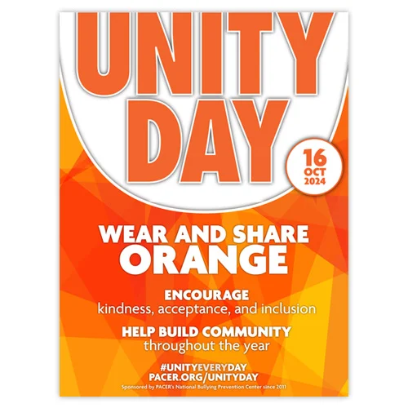

Breast Cancer Awareness Day

|  |
| --- |
| **October 18th, 2024 - Friday**  Wear and Share PINK  Show Your Support For  Breast Cancer Awareness |